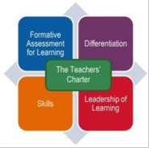
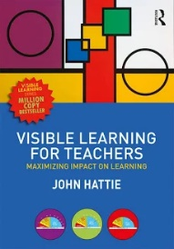
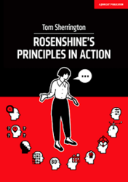
This Toolkit has been created in consultation with staff and Pupils at St JV. It outlines the core strategies staff and pupils should become confident, skilled or knowledgeable at using across the school, P1-7.

Research has heavily influenced the development of this Toolkit including:
- John Hattie’s, ‘Visible Learning’: Know thy Impact’
- Shirley Clark’s, ‘Outstanding Formative Assessment, Culture and Practice’
- Tom Sherrington’s, ‘Rosenshine’s Principals in Action’
- Paul Dix’s, ‘When Adults Change, Everything Changes’
- CEC Edinburgh Learns: ‘Teachers’ Charter’
- Education Scotland’s key documents including, ‘HGIOS4 2.3 Learning Teaching & Assessment’
- HOTS Questioning and Blooms Taxonomy
- HGIOS/HGIELC
- Realising the Ambition

- Edinburgh Learns: Teachers’ Charter.
As part of the CEC Edinburgh Learns Teaching and Learning Strategy, our teachers undertake key learning of the ‘Edinburgh Teachers’ Charter’. Our aim is that all teachers are skilled in these areas and that we see impact from this in the quality of learners’ experiences and attainment and achievement.
The Charter consists of 4 main parts. Online CPD is available for each via the following:links:https://online.clickview.co.uk/libraries/categories/38961906/teaching-and-learning
These core strategies, discussed and agreed by staff,
should be used throughout learning at StJV, at various
times, depending on the lesson and subject and at the
teachers’ professional discretion. Our aim is to continue
building ‘High Quality, Consistent Practice’, of strategies, skill
development and language of learning. Additional, strategies, may be used to supplement these strategies at the discretion of staff.

Our CORE strategies help create our ‘T&L Culture’.
This Toolkit is available on our school website: https://stjohnvianneyedinburgh.com

To be kept on a hook next to the class’s main T&L Board where L.I./WALT and S2S are displayed.


St John Vianney RC Primary School

‘T&L toolkit’
Part of the
‘St JV: Curriculum Guide’
Core strategies for
Teaching and Learning
leading to
High Quality, Consistent Practice

Version II
January 2017. Review May 2018.
Version 2: September 2022

To be kept on a hook next to the classes main T&L Board where L.I./WALT and S2S are displayed.

Rosenshine’s Principles of Instruction.
‘Rosenshine’s Principles in Action.’ Tom Sherrington
Read collectively by all teaching staff during session 2021/22, these principals, ‘provide ten research bases principles of instruction for classroom practice’. They are based on research of how our brain acquires and uses new information and research of classroom practices of those teachers whose pupils show the highest gains.
- Daily Review
- Present new material using small steps
- Ask questions
- Provide models
- Guide student practice
- Check for student understanding
- Obtain a high success rate
- Provide scaffolds for difficult tasks
- Independent practice
- Weekly and monthly review
Visible Learning: ‘Know Thy Impact’
The core message of Visible Learning is that ‘teachers need to be evaluators of their teaching impact’ It recentres the teacher’s perception to focus less on how they are teaching and more on how well their students are learning.

Hattie through his VL Research, tells us what is
effective in the classroom, (What strategies have
the most impact!) and what isn’t. The key is to,
‘Know Thy Impact’ and use strategies that have
the greatest impact. These include the influences
of the student, home, school, curricula, teaching
strategies and us!...and our belief in ‘making a difference’, ‘Collective Teacher Efficacy’.
Visible Learning is a key part of St JV’s T&L Guidance and Culture

StJV 4 Phase Teaching Model

Phase 1: Overview and Context
- A context for the lesson is shared with pupils and interest is generated. In this lesson we will…
- Short Review of prior learning: Establishing pupils’ Prior Knowledge and Understanding provides the key starting point from which to develop the next stages of learning.
- Learning intentions (L.I./WALT) are shared with pupils and displayed throughout the lesson.

Phase 2: Input
- Keep brief and does not exceed pupils' concentration span. (Consider a good balance between teacher talk versus pupil talk …..80:20 across the lesson)
‘Model, Model & Re-Model’
‘Guide Pupils Practice’
‘Minimise the chance of misconceptions’
- Model: to pupils the steps to complete the task and your expectation. Provide a scaffold for difficult tasks.
- ‘Modelling’ is a key part and should be provided every lesson.
Every Pupil must understand what ‘Excellent’ looks like!
‘I do, We do, You do’! (Tom Sherrington).

- ‘Steps to Success’-S2S- are co-constructed with pupils and displayed alongside L.I. throughout the lesson
- Teacher frequently asks (closed) questions to check for (surface) understanding.
- Higher Order questioning is embedded throughout.
- Visual, auditory and kinaesthetic learning styles should be included
- Teacher checks for understanding of task and WALT/LI & S2S

StJV 4 Phase Teaching Model
continued

Phase 3: Processing/Task/Activity

- Ensure pupils have access to scaffolds and modelled examples
- Independent practice for ALL pupils, with differentiated levels of support
- Checking for Understanding: ‘Mid-Lesson Learning Checks’ occur at least once throughout lesson. Refer to LI/S2S? Are pupils on track?
- Opportunities for pupils to seek clarification/ask questions.
- Opportunities to hear and see examples of pupils’ work, knowledge or skills (e.g., Use Visualiser to share a piece of work in progress).
- Pupils are given opportunities to apply skills and knowledge to real life experiences/examples.
- Support and Challenge opportunities.
Check for pupil understanding at each phase!

Phase 4: Review/Plenary
Always refer to WALT/L.I. and ‘S2S’
- Pupils encouraged to reflect on how they have learned to stimulate thought before future lessons.
- HOTS strategies/Effective Questioning used for ‘Checking for Understanding’ .
i.e., ‘Explain that to me…’ What strategy did you use?’, Can you tell me what you have understood?’
- Discuss ‘Next Steps’. Where do we move onto from here?

Learning Intentions and
‘Steps to Success-S2S’ (Success Criteria)
The L.I. and S2S are closely linked in every lesson.

- L.I.: emphasis is on learning rather than doing. Learning intentions help pupils to focus, not on a task or activity, but on what they will learn from doing it. Focus on the skills and knowledge being taught.

- N-P3 will use the term WALT (We are learning to) when referring to the Learning Intentions
- P4-P7 will use Learning Intention: (L.I.)
Good examples
- We are learning to work effectively in groups
- We are learning to use evidence to support an opinion
- We are learning to conduct a fair test
- N-P7 will use the term, Steps to Success ’S2S’:
Are linked to the learning intention & are specific to a lesson. They should be co-constructed with pupils after being exposed to the learning focus. They are used as the basis for feedback, teacher, peer and self-assessment.
Good ‘Steps to Success- S2S’ provide steps pupils can check against. They are not necessarily linear. They ask pupils how they know they have achieved success in their learning.
L.I. and S2S are always displayed and referred to (‘Mid Lesson Checks’) throughout the lesson for pupil self-assessment, keeping pupils on track.
S2S are co-created at the end of the lesson’s input section.
P5-P7 write the L.I. in their jotters/on the work sheet.

Daily, Weekly and Monthly Review‘
‘More effective teachers routinely engage students in a variety of forms of retrieval practice, recalling and applying previously learned material’ Tom Sherrington pp. 37.

Making it part of an effective and sustainable routine by:

- Daily review: Begin the lesson with a short review of previous learning, reteach where necessary, ensuring pupils have ‘corrected’ errors or misconceptions. See Sherrington page 62.
- Involve everyone
- Make (pupil) checking accurate and easy
- Specify the knowledge: Student’s knowing the knowledge so they can self-check
- Keep it generative: pupils need to explore their memory to check what they know & understand. This means removing cue cards and prompts, closing jotters etc. and making pupils think for themselves!
- Vary the diet: mix up the various strategies used: For example: self-quizzing, telling the story, multiple choice, and open response tests, rehearsing explanations, summarising, creating knowledge maps, pupils teaching others as ‘teacher’, demonstrating and performance.
- Make it time efficient: A good technique can be used repeatedly in an efficient manner
- Make it workload efficient: the best methods do not involve teachers checking student answers.

Find and use the strategies and systems that have the greatest impact with your pupils.

Checking for Understanding and Progress

Examples of Feedback Approaches during the lesson:
- Cold Calling or Random Selection: Lollipop sticks, seat number
- ‘NO- HANDS-UP’ combined with pupils having Thinking Time
- Talking/Shoulder/Face Partners/EEKK positions
- Thumbs Up-Middle-down/Fist to Five
- Traffic Lights: Green/Orange/Red
- 2 Stars and Wish (written or verbal)
- Hinge Question

Examples of Feedback Approaches to use for Plenary
The L.I. and ‘S2S’ must always be referred to in every Plenary.
1. Plenary Dice:
What did I learn today?, What did I find most difficult? What could I learn next?, What did I find most helpful?
How can I improve next time? Other?!
2. True / False: Write 3 true and 3 false statements based upon the learning.
4. Exit Question
5. Top Tips: 3-5 Top Tips covered in the lesson.
6. Share with your ‘Talking Partner’ skills you have learned.

Examples of 1:1/Small Group Intervention Approaches
- Regular, at least Weekly, 1:1 Teacher-Pupil meeting has the greatest impact on Attainment. (Hattie/Clark)
- ‘Not-On-Track’ pupils should meet with their CT at least weekly in the relevant subject
- Yellow Box Marking: i.e. up levelling writing or other work so pupils are developing and improving skills
- Correct Misconceptions/mistakes
- Repeat work to act on feedback and eliminate incorrect learning
- Setting small, daily/weekly/termly targets
- Consolidating learning

HOTS: Planning and Questions to ask pupils
Bloom’s taxonomy is a useful model for examining and differentiating the challenge levels of learning tasks and discussion questions in all subjects. It enables the teacher to look at instruction through the lens of challenge.
Bloom’s taxonomy enables the teacher to categorise activities and questions by level of complexity, thereby ensuring that a wider range of higher-order thinking challenges are provided to children.

In addition to this, Bloom’s taxonomy higher levels of thinking reinforce basic content For example, asking children to identify a
problem in a story and come up with an alternative solution (analysis and evaluation) requires them to revisit the story and recall the original solution (knowledge and comprehension).

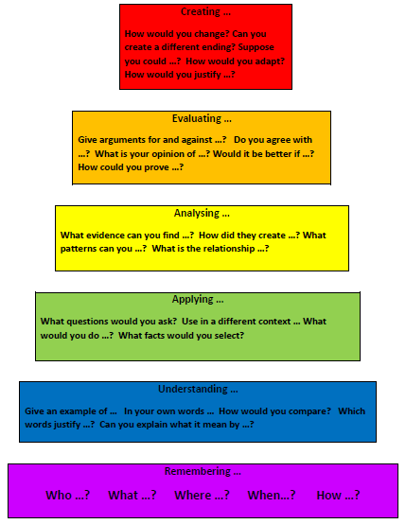

Core parts of Curriculum for Excellence

4 Capacities
Responsible Citizens Effective Contributors
Confident Individuals Successful Learners

8 Curricular Areas
Languages Mathematics and Numeracy
Health and Wellbeing RERC
Sciences Technologies
Social Studies Expressive Arts

7 Principles
Breadth Depth
Progression Relevance
Coherence
Challenge and Enjoyment
Personalisation and Choice

4 Contexts
- Ethos and life of the school as a community
- Curriculum areas and subjects
- Interdisciplinary learning
- Opportunities for personal achievement

